

PET REGISTRATION

PET'S NAME: 1.________________________________ 2.________________________________

BREED: 1.________________________________ 2.________________________________

D.O.B.: 1.____/_____/_____ Female / Male 2._____/_____/_____ Female / Male

CURRENT SIZE: 1. SMALL / MEDIUM / LARGE 2. SMALL / MEDIUM / LARGE

Length of back - neck to tail (cm’s): _______ ___ Circumference around chest (cm’s): __________

OWNER’S NAME: ___________________________________________________________________________________

PHONE: (1)_____________________________ (2) _____________________________ (two numbers required)

SUBURB: _____________________________________ STATE___________

EMAIL: __________________________________________________ WORKING WITH CHILDREN CHECK? YES / NO

PET INSTAGRAM ACCOUNT: YES / NO NAME: _________________________________________

PET’S TRAINING LEVEL: (Please circle if your pet will RELIABLY do these actions on command.)
 | DOGS
 | SIT AND STAY (for at least 20 seconds) | YES | NO
 | LIE DOWN AND STAY (for at least 20 seconds) | YES | NO
 | COME WHEN CALLED | YES | NO
 | COMFORTABLE/FRIENDLY WITH OTHER DOGS | YES | NO
 | COMFORTABLE/FRIENDLY WITH CHILDREN | YES | NO
 | RESPONDS TO YOUR VOICE COMMANDS | YES | NO
 | RESPONDS TO YOUR HAND SIGNALS | YES | NO
 | BARKS ON COMMAND | YES | NO
 | COMFORTABLE SWIMMING IN A POOL/OCEAN | YES | NO
 | WILL CARRY AN OBJECT IN ITS MOUTH | YES | NO
 | LIVES COMFORTABLY WITH A CAT | YES | NO
 | WILL RESPOND TO COMMANDS WHILE OFF LEAD | YES | NO
 | WILL SIT/STAY CALMLY IF A VACUUM IS ON NEARBY | YES | NO
 | SPIN AROUND IN A CIRCLE ON COMMAND | YES | NO
 | CAN REST HEAD DOWN ON THE FLOOR ON COMMAND | YES | NO
 | CAN HOWL ON CUE | YES | NO
 | CAN CATCH A FRISBEE | YES | NO
 | CATS
1 | COMFORTABLE BEING HELD BY A STRANGER | YES | NO
2 | USED TO BEING IN DIFFERENT ENVIRONMENTS | YES | NO
3 | WILL STAY IN ONE SPOT RELIABLY | YES | NO
4 | HAS A CALM/PLACID NATURE | YES | NO
5 | LIVES COMFORTABLY WITH A DOG | YES | NO
6 | COMFORTABLE TO WALK ON A LEAD/HARNESS | YES | NO
There is a $120.00 registration fee (plus $12 gst) = TOTAL: $132.00 to have your pet’s photos on our website for 12 months. (Additional pets 50% off.) This also covers administration time, marketing, liaising with clients to get work for your pet, website costs, insurance, editing/updating photos and videos. These will be available for production companies to view for their upcoming jobs. Our clients choose the animals they want; there is no favouritism. (If your pet isn’t chosen for a job within 12 months, you will receive an optional additional 6 months free of charge.)

PAYMENT:

Bank transfer: | Commonwealth Bank
Account name: | Animal Extras
BSB number: | 063188
Account number: | 10450978 (Please quote invoice number or your pet’s name)
Credit Card Payment:  Name on card:  Card number:  Note: | Visa / Mastercard / Amex (add 2% surcharge)  _________________________________________  __ __ __ __ __ __ __ __ __ __ __ __ __ __ __ __ Exp: ____ / ____  Security code: __ __ __  Your credit card will NOT automatically be charged for renewal after 12 months. Will we email a renewal invoice for you to authorise.
PHOTOS TO SEND:

3 HEAD SHOTS **LOOKING AT CAMERA / PORTRAIT**
3 FULL BODY SHOTS **STANDING / SIDE ON / LANDSCAPE**

They need to be clear (not blurred) with no other animals/people and no doggy clothes, as the clients need to be able to see their body/shape/colour/size! We will choose 1 head shot and 1 body shot to go on our website. The photos should be similar to these:

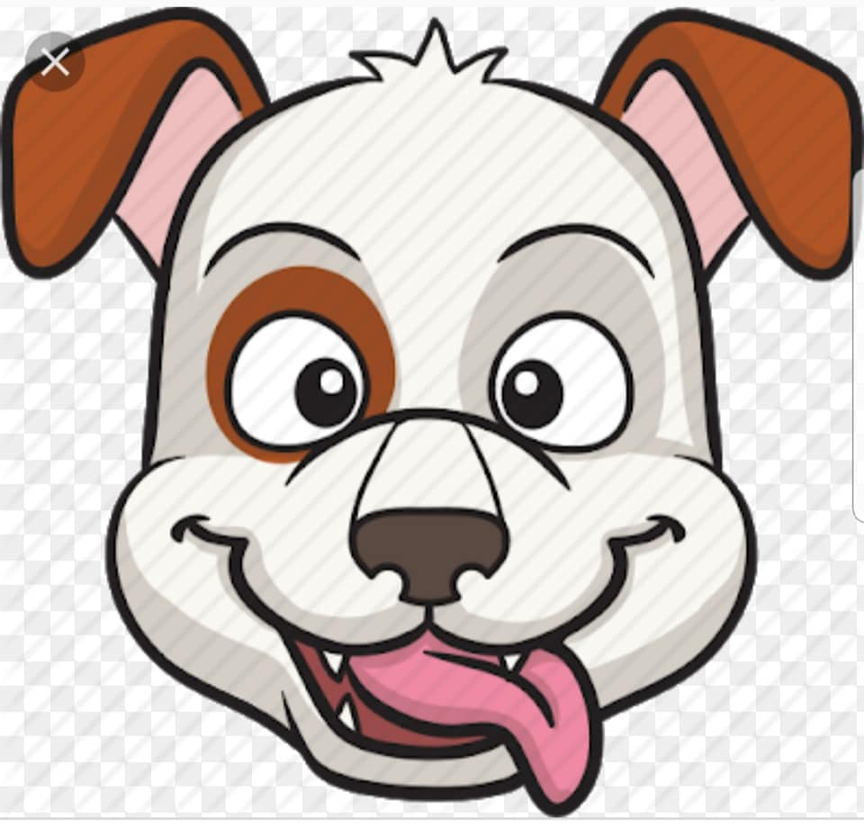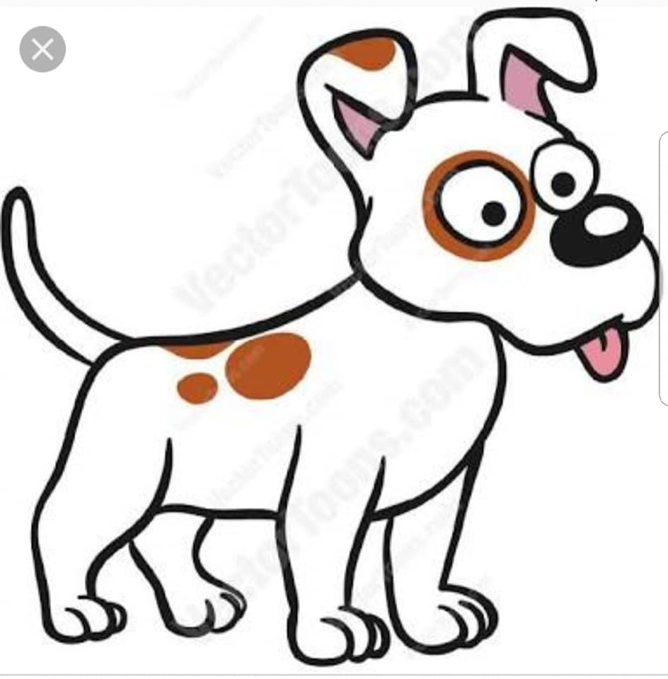

TIPS FOR ATTENDING JOBS

- You have the option to attend all jobs. (You must advise if you will not be attending.)
- Please always arrive early to allow time for parking. All phones must be on silent.
- Please do not take photos or videos without asking permission from one of the crew.
- One other person may attend with you. (Children: please have someone to supervise them.)
- Photo shoots work at a fast pace, please be ready for each “take” and work quickly to put your pet back into the required position (if you are doing the handling on set of your pet).
- TV commercials and films work at a slower pace. Take warm clothing, a bed for your dog, or secure carrier and litter tray for your cat, water bowl, your pet’s favourite treats and toys.
(We prefer it if your pet is fed AFTER their shoot, rather than before.)
- If you would like to receive a copy of your pet’s job, please *exchange email addresses* with the contact person on set. We usually don’t receive copies, so this is important!
- Please only park where instructed to on the call sheet. (Fines will not be reimbursed.)
- Your pet must have an ID tag on its collar at ALL times on a job and be kept on a leash.
- Your pet will be under the control of one of our handlers (or yourself) during filming.
- Your pet will have fresh water available at all times during jobs. (Please take favourite treats.)

TERMS AND CONDITIONS

- One membership requirement is that you’re not registered with another agency at the same time.
- We have public liability insurance but can’t be held liable for an incident resulting in damage to persons, animals or property during, or while travelling to/from a job.
- If you partake in a job via Animal Extras, if you’re contacted by that company for more work, you’ll refer them to us. Registration will be cancelled if this is not adhered to, with no refund.
- If your pet is involved in media coverage not booked via Animal Extras, you agree you’ll mention your pet is registered with us and ask if this can be included in the publication.
- If a production agency requires a “medical” test, this is undertaken between you and the company making the booking. Animal Extras has no part in being responsible for or requesting any tests. It is your personal choice if you take a test upon a request from one of these companies.
- You will be paid directly by Animal Extras, being your agent. Registration is non-refundable.
- You will advise Animal Extras if your pet has ever been aggressive. If it causes injury on a job, we will provide your details and it must be settled between you and the other party. If your pet requires a vet due to an incident on a job, all fees must be settled by you with the vet.
- You will advise Animal Extras if your pet has any health conditions or is currently pregnant.
- You understand that registering your pet does not guarantee work for your pet(s).
- You are not permitted to post (on social media) the company name of any job that your pet will be working on until after it is available to the public (incl. behind the scenes photos.)
- You are not permitted to discuss monetary payments with anyone on the set of a job.
- You have read and agree with all the above terms and conditions.

Name: ……………................................. Signature: .............................................. Date: ......./…..../.......

PLEASE EMAIL THIS FORM (signed) WITH YOUR PHOTOS TO:
Sue : admin@animalextras.com.au
** KEEP AN EYE ON OUR FACEBOOK PAGE **
** We will contact you if your pet is chosen for a job **

